A linked list is a sequence of data structures, which are connected together via links.

Linked List is a sequence of links which contains items. Each link contains a connection to another link. Linked list is the second most-used data structure after array. Following are the important terms to understand the concept of Linked List.

* **Link** − Each link of a linked list can store a data called an element.
* **Next** − Each link of a linked list contains a link to the next link called Next.
* **LinkedList** − A Linked List contains the connection link to the first link called First.

Linked List Representation

Linked list can be visualized as a chain of nodes, where every node points to the next node.

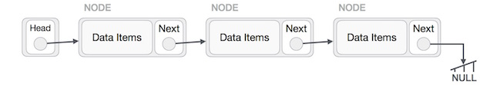

## Types of Linked List

Following are the various types of linked list.

* **Simple Linked List** − Item navigation is forward only.
* **Doubly Linked List** − Items can be navigated forward and backward.
* **Circular Linked List** − Last item contains link of the first element as next and the first element has a link to the last element as previous.

## Basic Operations

Following are the basic operations supported by a list.

* **Insertion** − Adds an element at the beginning of the list.
* **Deletion** − Deletes an element at the beginning of the list.
* **Display** − Displays the complete list.
* **Search** − Searches an element using the given key.
* **Delete** − Deletes an element using the given key.

## Operations on Singly Linked List

There are various operations which can be performed on singly linked list. A list of all such operations is given above.

### Node Creation

struct node

{

**int** data;

    struct node *next;

};

struct node *head, *ptr;

ptr = (struct node *)malloc(sizeof(struct node *));

## Insertion Operation

Adding a new node in linked list is a more than one step activity. We shall learn this with diagrams here. First, create a node using the same structure and find the location where it has to be inserted.

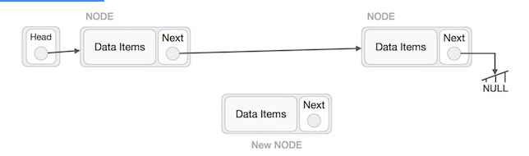

Imagine that we are inserting a node **B** (NewNode), between **A** (LeftNode) and **C** (RightNode). Then point B.next to C –

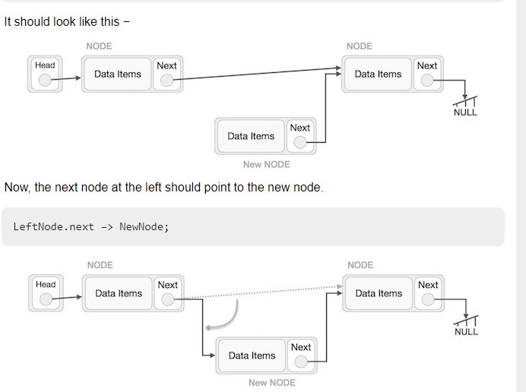

Similar steps should be taken if the node is being inserted at the beginning of the list. While inserting it at the end, the second last node of the list should point to the new node and the new node will point to NULL.

## Deletion Operation

Deletion is also a more than one step process. We shall learn with pictorial representation. First, locate the target node to be removed, by using searching algorithms.

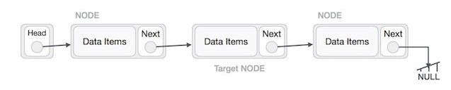

The left (previous) node of the target node now should point to the next node of the target node –

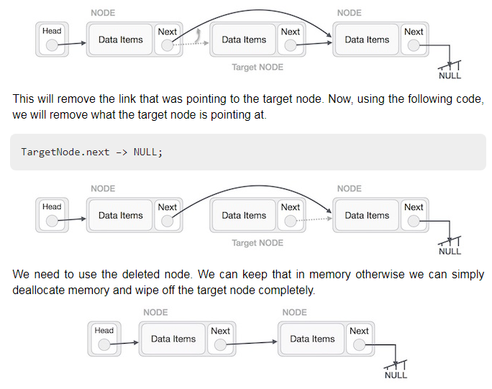

Create a node in singly link list and display it

#include <stdio.h>

#include <stdlib.h>

struct node

{

int num; //Data of the node

struct node *nextptr; //Address of the next node

}*stnode;

void createNodeList(int n); // function to create the list

void displayList(); // function to display the list

int main()

{

int n;

printf("\n\n Linked List : To create and display Singly Linked List :\n");

printf("-------------------------------------------------------------\n");

printf(" Input the number of nodes : ");

scanf("%d", &n);

createNodeList(n);

printf("\n Data entered in the list : \n");

displayList();

return 0;

}

void createNodeList(int n)

{

struct node *fnNode, *tmp;

int num, i;

stnode = (struct node *)malloc(sizeof(struct node));

if(stnode == NULL) //check whether the fnnode is NULL and if so no memory allocation

{

printf(" Memory can not be allocated.");

}

else

{

// reads data for the node through keyboard

printf(" Input data for node 1 : ");

scanf("%d", &num);

stnode->num = num;

stnode->nextptr = NULL; // links the address field to NULL

tmp = stnode;

// Creating n nodes and adding to linked list

for(i=2; i<=n; i++)

{

fnNode = (struct node *)malloc(sizeof(struct node));

if(fnNode == NULL)

{

printf(" Memory can not be allocated.");

break;

}

else

{

printf(" Input data for node %d : ", i);

scanf(" %d", &num);

fnNode->num = num; // links the num field of fnNode with num

fnNode->nextptr = NULL; // links the address field of fnNode with NULL

tmp->nextptr = fnNode; // links previous node i.e. tmp to the fnNode

tmp = tmp->nextptr;

}

}

}

}

void displayList()

{

struct node *tmp;

if(stnode == NULL)

{

printf(" List is empty.");

}

else

{

tmp = stnode;

while(tmp != NULL)

{

printf(" Data = %d\n", tmp->num); // prints the data of current node

tmp = tmp->nextptr; // advances the position of current node

}

}

}